**Project report for**

**Internship/ Training at**

**Directorate of Ordnance (C&S)**

Title

**Rajarhaat Guest Room Online Booking System**

By

Aritra Naskar

Student of Netaji Subhash Engineering College

Computer Science and Engineering

3rd year, roll no – 10900120118

14th July, 2023

**Acknowledgement :-**

I, Aritra Naskar, am a student of Netaji Subhas Engineering College, Garia. I have just completed 3rd year of my B. Tech in Computer Science and Engineering. I feel proud to get the chance to do internship/ training at **Directorate of Ordnance (C&S), Kolkata under Ministry of Defence, Government of India.**

During my internship I was assigned with the job:

There is a guest house of DoO(C&S) at Rajarhaat, New Town, Kolkata. I was assigned to make web page for booking room at that guest room. I prepared the web page and a report thereon.

During my internship/ training, I was guided by the extremely proficient and expert officers of IT division of DoO(C&S). I am thankful for the whole hearted support and guidance of the following mentor/Officers:

1. Smt. Sumita Mansukhani, Deputy Director General/ IT
2. Shri Tausif Ahmad, Deputy Director/ IT
3. Shri Mithun Kumar Das, Head of Section/ IT
4. Smt. Soumita Dasgupta, Junior Works Manager/ IT
5. Shri Baiju Kumar, Junior Works Manager/ IT
6. Shri Ravi Shankar Majumdar, Junior Works Manager/ IT

While doing this internship/ training at DoO(C&S), Kolkata, I had to study a new language ‘PHP’ and designing language Bootstrap which helped me to build the website. During my training, I was stuck at different levels and I could overcome those difficulties with the help of my mentors. I learnt several new things during this training which will help me in my future work area.

I again convey my heartfelt thanks to everyone of DoO(C&S), Kolkata who helped me a lot in executing my entrusted jobs.

Aritra Naskar

Student of Netaji Subhash Engineering College

Computer Science and Engineering

3rd year, roll no – 10900120118

**Index**

**Introduction** ………………………………………………………………….. 03

**Functionalities** ………………………………………………………………. 05

**System Flow Chart** ………………………………………………………… 15

**Database Structure** ……………………………………………………….. 16

**Software Requirement** ………………………………………………….. 17

**Conclusion** …………………………………………………………………….. 18

**Introduction**

The Online Room Booking System is a project implemented for Rajarhaat Guest Room of Directorate of Ordnance (C & S). It provides users with an easy and fast way to book rooms online.

The web interface of the Online Room Booking System can be accessed with any modern web browser. The system is implemented in HTML (Hyper Text Markup Language), CSS (Cascading Style Sheet), Bootstrap, JavaScript, PHP (Hypertext Preprocessor) and MySQL. Users can perform room booking activities at Rajarhaat Guest Room anytime and anywhere by accessing it via internet.

The Online Room Booking System is an easy-to-use application. Everyone who knows how to use a web browser can easily carryout booking, change the booking details, cancel the booking or view the hotel information by following its simple and clear GUI (Graphical User Interface) design.

To enhance user satisfaction and convenience, the Online Room Booking System provides comprehensive features and functionalities. These include detailed Guest Room descriptions, high-resolution images to give users clear understanding of each hotel’s facilities and location. The platform also offers flexible booking options, allowing users to modify or cancel their reservations easily. By prioritizing user experience and establishing strong partnership, the Online Room Booking System aims to become trusted and reliable.

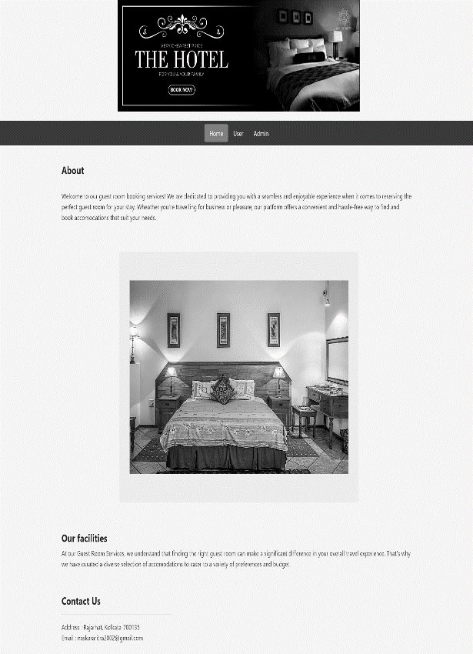

**Functionalities**

**User Login** :-

* This feature is used by the user to login into the system.

**Input**: - User will have to input corresponding username and password.

**Output**: - System will allow the user to login if the correct username and password is provided.

- If the above condition is not met, the system will not allow the user to login and it will display an error message.

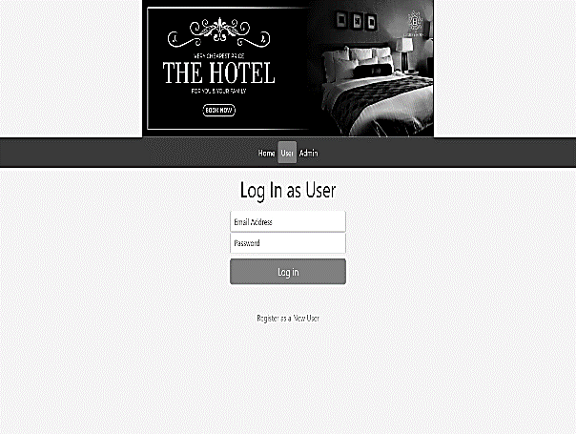

**Register New User** :-

* This feature can be performed by anyone to register new users to create account.

**Input**: - New user’s name, phone number, email address and password for further login.

**Output**: - System will create a new user account if no previous accounts exists with the same email and all fields are filled properly.

- If the credential is not valid or user already exists then it will display an error message.

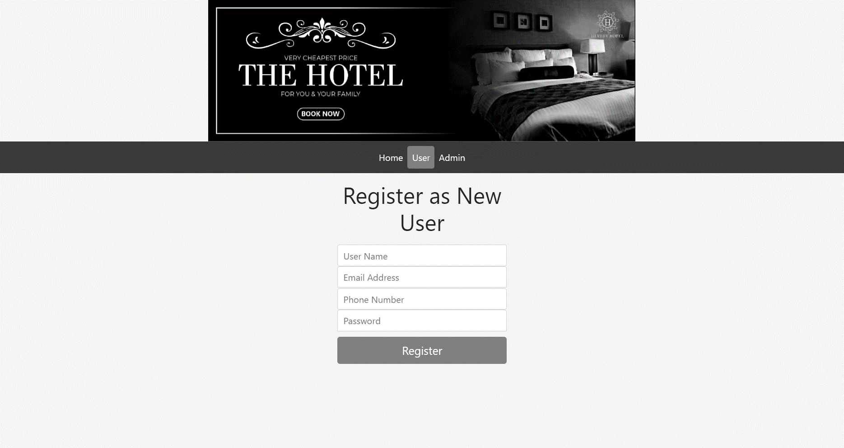

**Place new booking** :-

* This feature can be performed by user to place a booking order.

**Input**: - Check In Date, Check Out Date, Room Type.

**Output**: - System will place the order in a queue for booking.

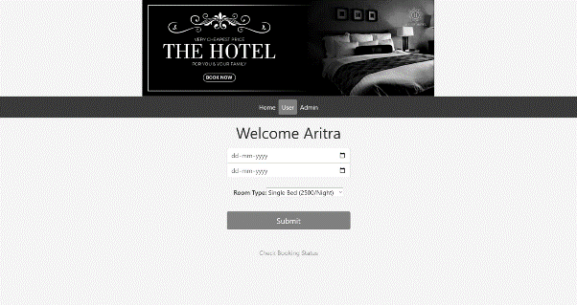

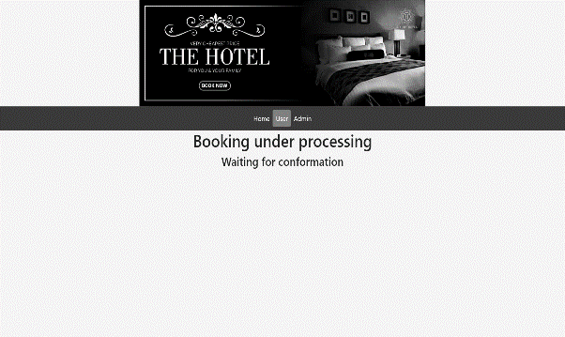

**Check Booking Status** :-

* This feature can be performed by user to check if the booking has confirmed or not.

**Input**: - N/A.

**Output**: - System will show if the booking is pending, confirmed or no booking yet.

- A cancel button to cancel the booking.

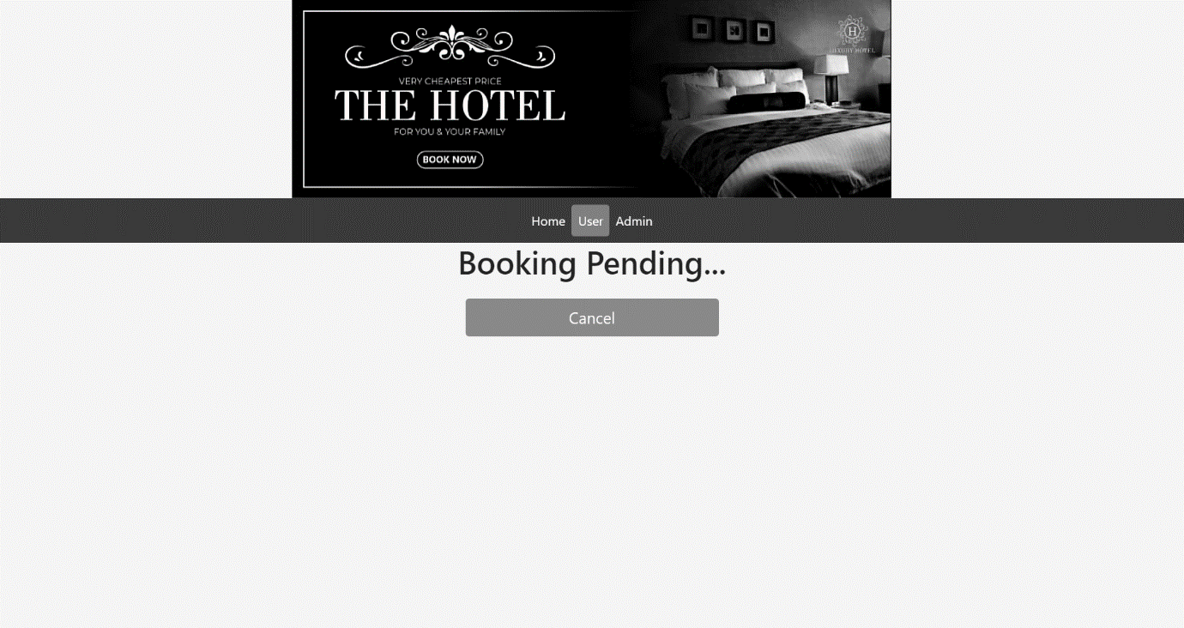

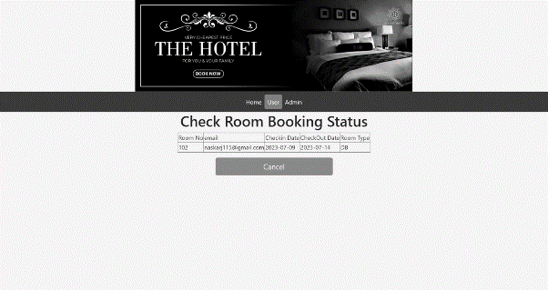

**Admin Login** :-

* This feature is used by the admin to login into the

system.

**Input**: - Admin will have to input corresponding username and password.

**Output**: - System will allow the Admin to login if the correct username and password is provided.

- If the above condition is not met, the system will not allow the Admin to login and it will display an error message.

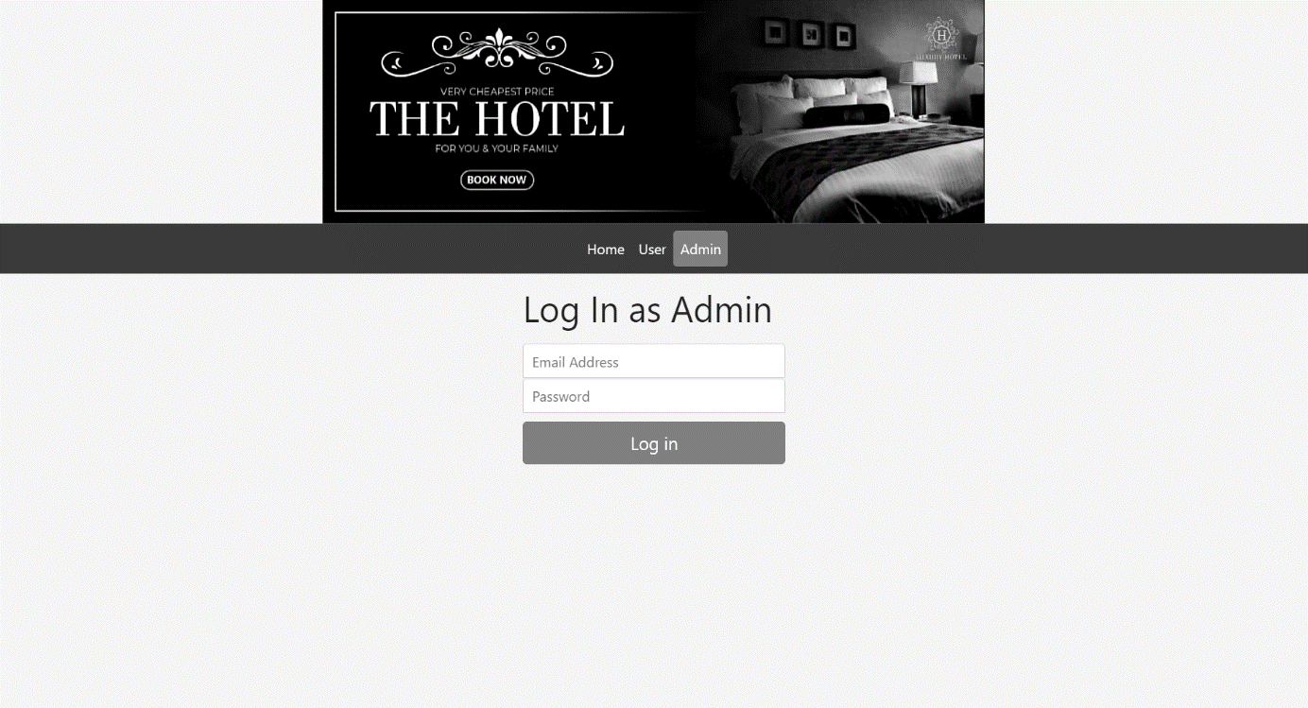

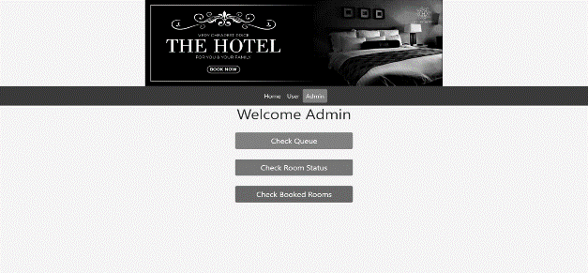

**Check Queue** :-

* This feature is used by the admin to check booking queue.

**Input**: - Admin can confirm booking.

**Output**: - System will check if another existing booking

time conflicts with new booking time.

- If the above condition is not met, the system will confirm booking or else the system will send an error message.

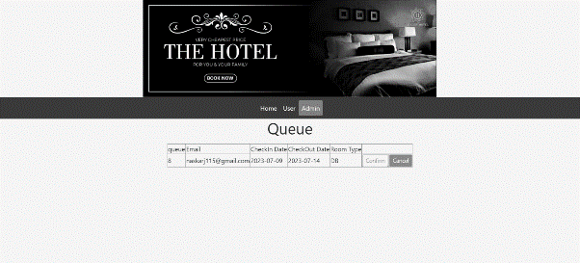

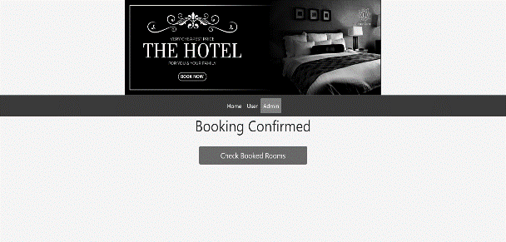

**Check Room Status** :-

* This feature can be performed by Admin to check room status.

**Input**: - N/A.

**Output**: - Details of all rooms will be shown.

- A room update and add new room button will be shown.

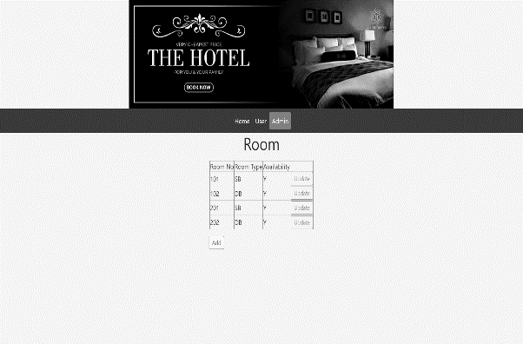

**Update Room Status** :-

* This feature can be performed by Admin to update room status.

**Input**: - ‘N’ if the room is in maintenance and ‘Y’ if the room is available for further booking.

**Output**: - Room status will be updated.

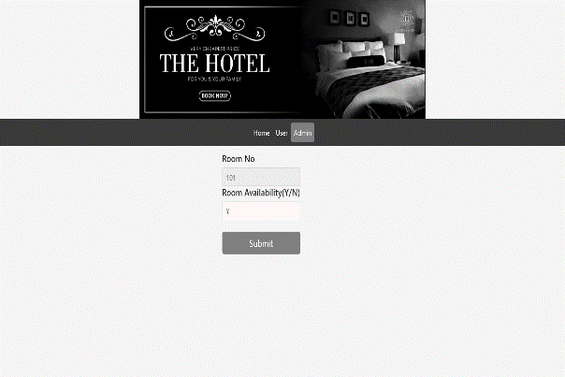

**Add New Room** :-

* This feature can be performed by Admin to add new room.

**Input**: - Room no, Room type and availability should be inputted for new room.

**Output**: - New room will be added if no previous room exists with same room no.

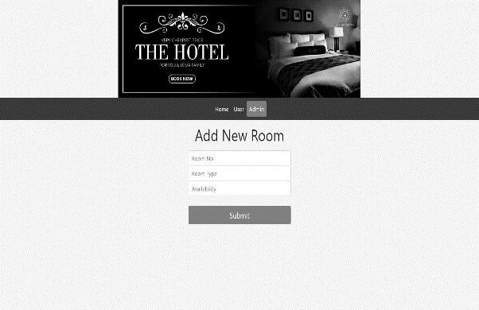

**Check Already Booked Rooms** :-

* This feature can be performed by Admin to check already booked rooms.

**Input**: - N/A.

**Output**: - System will show all already booked rooms

where users are currently staying or will stay in future.

- A cancel button to cancel booking.

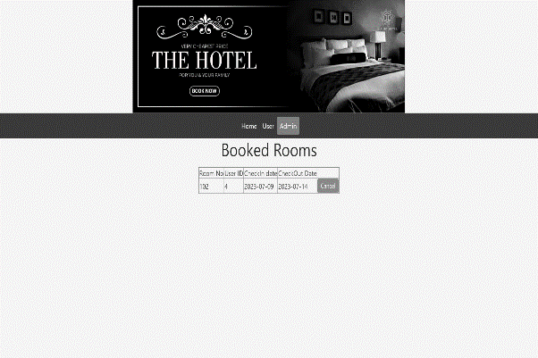

**System Flow Chart**

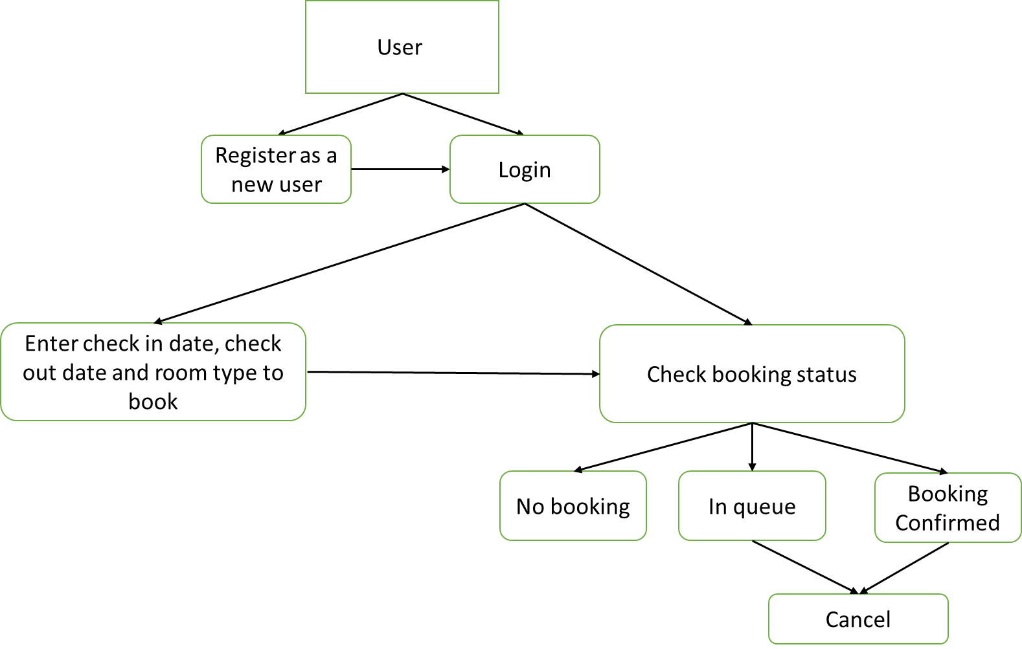

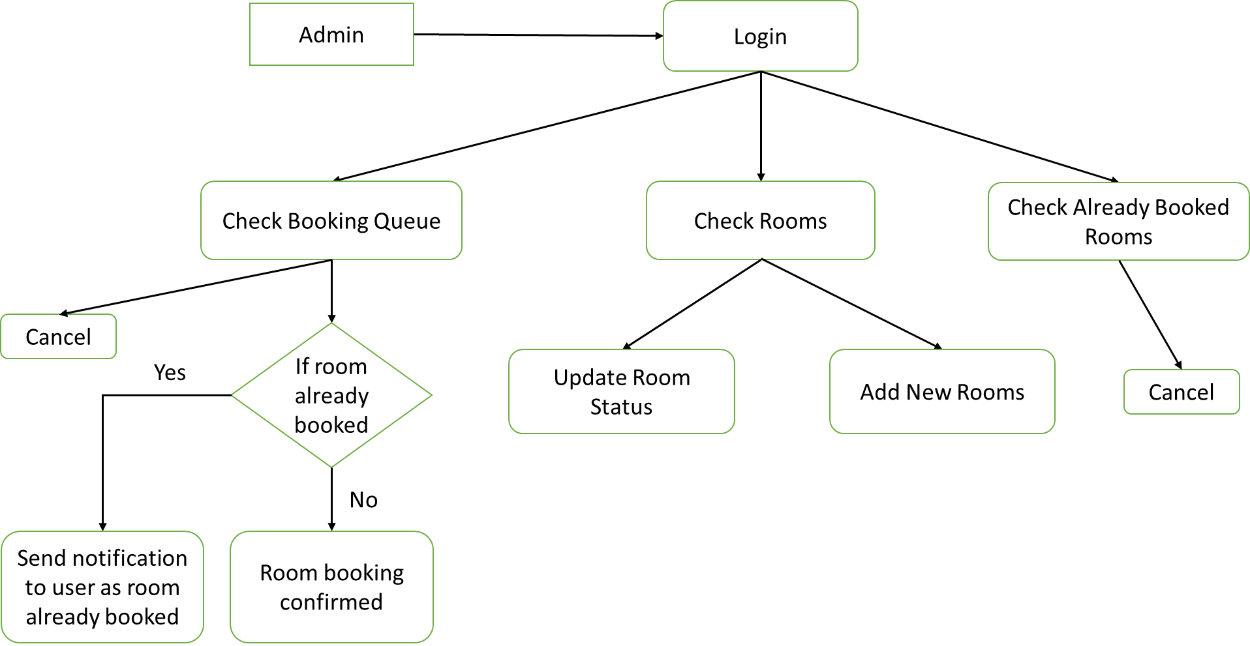

**Database Structure**

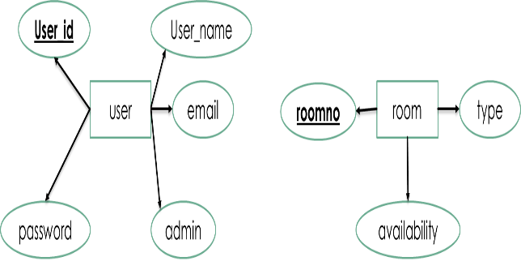

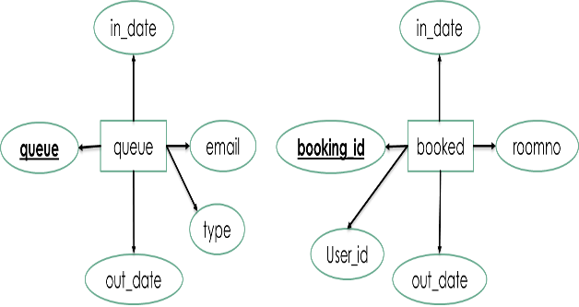

**Software Requirement**

* **Operating System:** Windows 10 is used as the operating system as it is stable and supports more feature and more user- friendly.
* **Database:** MySQL is used as a database as it is easy to maintain and retrieve records by simple queries which are in English language which are easy to understand and easy to write.
* **Development Tools and Programming Language:**

HTML is used to write the whole code and develop web pages with CSS, JavaScript and Bootstrap for styling work and PHP for server side scripting.

**Software Tools Used :-**

* **Front End:** The front end is designed using HTML, CSS,

Bootstrap and JavaScript.

* **Back End:** The back end is designed using MySQL and

PHP.

|  |  |
| --- | --- |
| Operating System | Windows 10 |
| Memory | 16 GB |
| Hard Disk Space | Minimum 3 GB for database usage |
| Database | MySQL |
| Technology | HTML, CSS, JavaScript, Bootstrap, PHP |

**Conclusion**

In conclusion, the development and implementation of the room booking system project have proven to be a significant success. This project aimed to automate the process of booking rooms. Through careful planning, effective collaboration and the utilization of advanced technologies, we have delivered a robust and reliable system.

Firstly, the system has successfully automated the booking process, eliminating the need for manual paperwork and reducing the chances of errors or double bookings. The user-friendly interface has made it easier for individuals to search for available rooms, view their details and make reservations seamlessly. This has resulted in a smoother and more streamlined experience for users, saving time and effort.

Additionally, the system has provided administrators with valuable tools for managing and monitoring room reservations. They can easily track room availability, manage booking requests and gain insights into usage patterns. This has enabled better resource allocation, improved decision-making and optimized utilization of available spaces.

Overall, the room booking system has proven to be a valuable asset for the organization, enhancing efficiency, improving user experience and optimizing resource management. The project has fulfilled its objective and has set a solid foundation for future enhancements and advancements in managing room reservation.